Social Interaction: Observation Form and Rubric
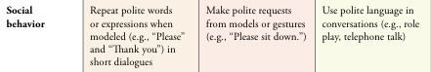
Beginning of Unit Date:_______________ Rubric Score: ____________
Activity | Observation Notes | Vocabulary & Sentence Starters used
Midpoint of Unit Date:_______________ Rubric Score: ____________
Activity | Observation Notes | Vocabulary & Sentence Starters used
End of Unit Date:_______________ Rubric Score: ____________
Activity | Observation Notes | Vocabulary & Sentence Starters used

